ASSIGNMENT NO.5: Aggregate Functions and Data

Analysis

QUESTION.1
Q1) Create a MySQL database named CollegeDB and a table named StudentResult.
The table should contain the following columns: Column Name Data Type StudentID Constraint INT StudentName VARCHAR(50) Course PRIMARY KEY City VARCHAR(30) VARCHAR(30) Marks FeesPaid INT
DECIMAL(10,2) Insert at least 10 records into the table.
Query
CREATE DATABASE CollegeDB;
USE CollegeDB;

CREATE TABLE StudentResult ( StudentID INT PRIMARY KEY,
StudentName VARCHAR(50), Course VARCHAR(30),
City VARCHAR(30),
Marks INT,
FeesPaid DECIMAL(10,2)
);

INSERT INTO StudentResult
(StudentID, StudentName, Course, City, Marks, FeesPaid) VALUES
(1, 'Aarav Sharma', 'B.Sc. Data Science', 'Pune', 85, 55000.00),
(2, 'Sneha Patil', 'B.Sc. Data Science', 'Mumbai', 78, 55000.00),

(3, 'Rahul Joshi', 'B.Sc. Data Science', 'Pune', 92, 55000.00),
(4, 'Priya Shah', 'BCA', 'Nashik', 74, 48000.00),
(5, 'Rohan Deshmukh', 'BCA', 'Pune', 81, 48000.00),
(6, 'Ananya Kulkarni', 'BCA', 'Mumbai', 69, 48000.00),
(7, 'Vikram Singh', 'BBA', 'Delhi', 88, 45000.00),
(8, 'Isha Mehta', 'BBA', 'Pune', 76, 45000.00),
(9, 'Karan Verma', 'B.Com', 'Mumbai', 64, 42000.00),
(10, 'Neha Gupta', 'B.Com', 'Pune', 91, 42000.00);

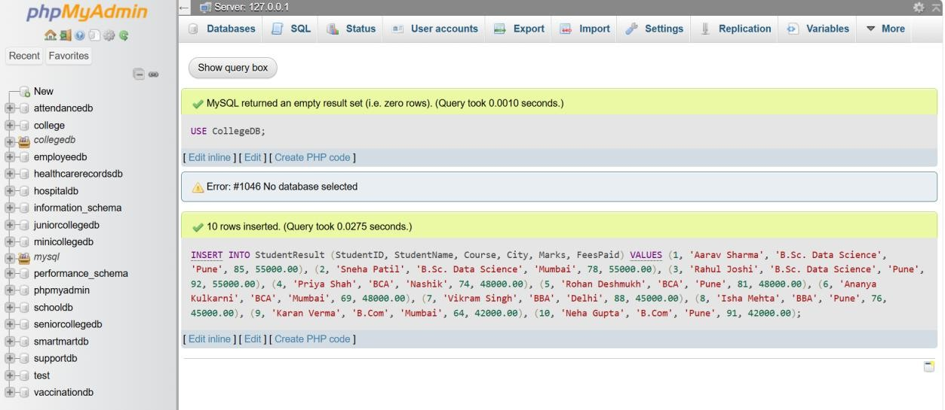

QUESTION2
Q2) Write MySQL queries to find the following from the StudentResult table: Requirement Total number of students Total fees paid Average marks Lowest marks Highest marks

QUERY

SELECT COUNT(*) AS TotalStudents FROM StudentResult;

SELECT SUM(FeesPaid) AS TotalFeesPaid

FROM StudentResult;

SELECT AVG(Marks) AS AverageMarks FROM StudentResult;

SELECT MIN(Marks) AS LowestMarks FROM StudentResult;

SELECT MAX(Marks) AS HighestMarks FROM StudentResult;
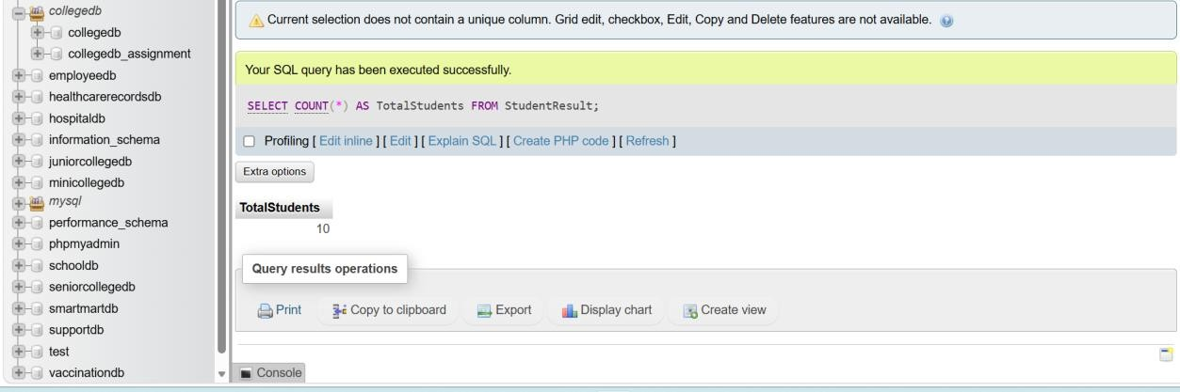


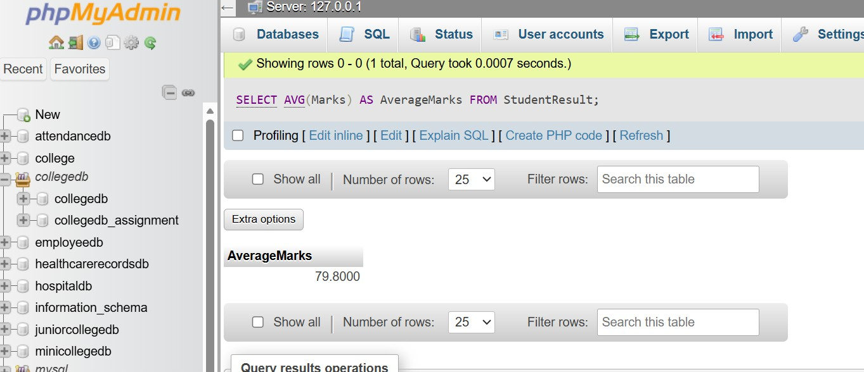
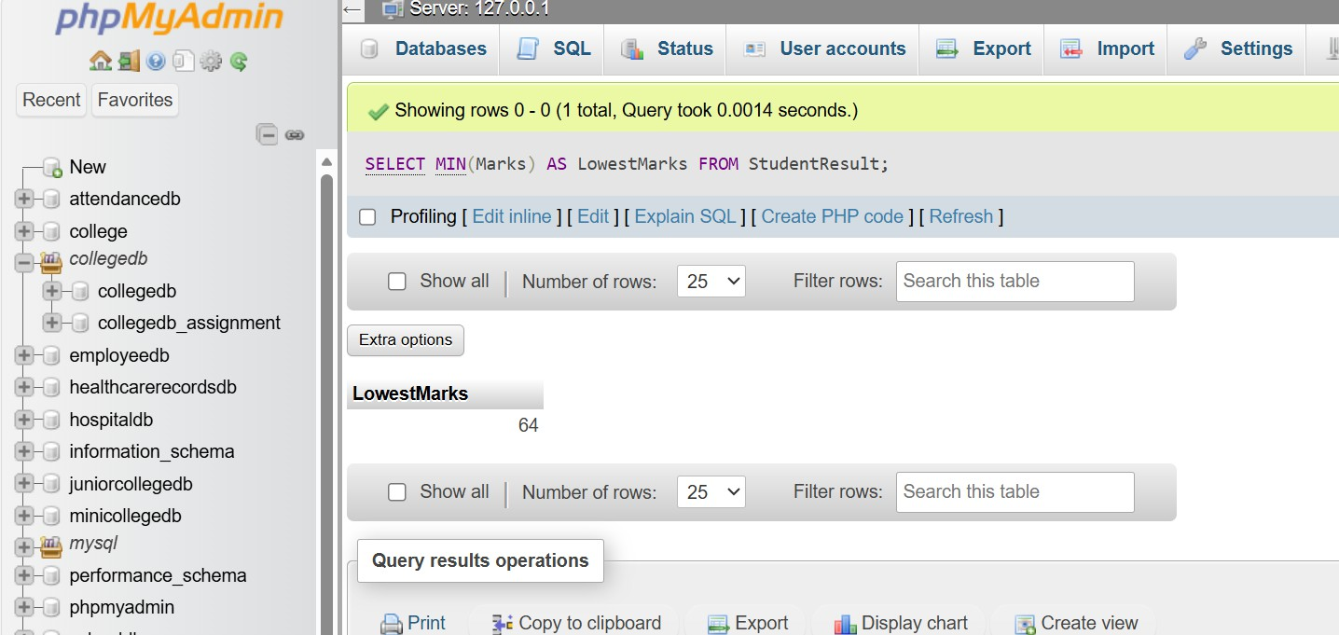
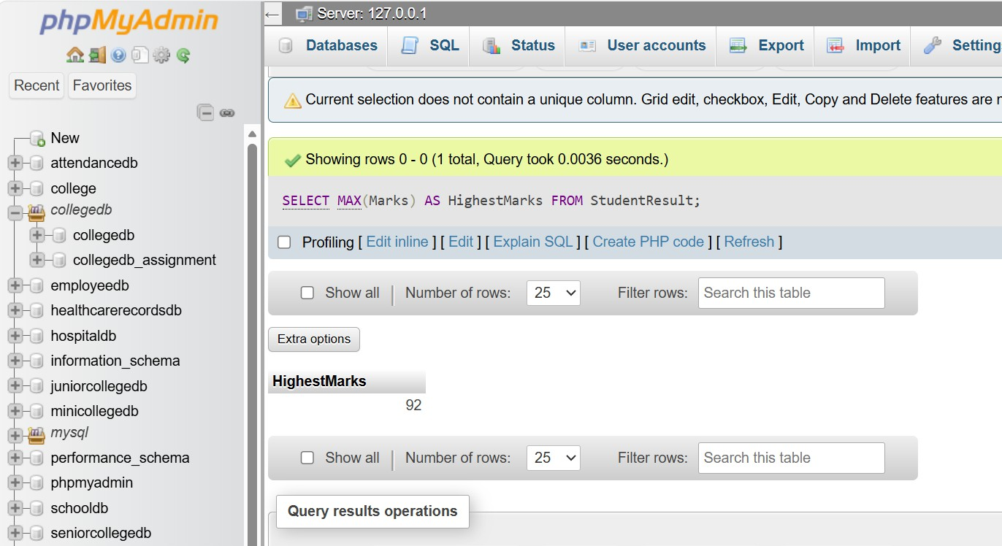

QUESTION 3
Q3) Write a MySQL query to count the number of students in each course. The output should contain: Column Course TotalStudents

QUERY
SELECT COURSE, COUNT(*) AS TotalStudents FROM studentresult
GROUP BY course;
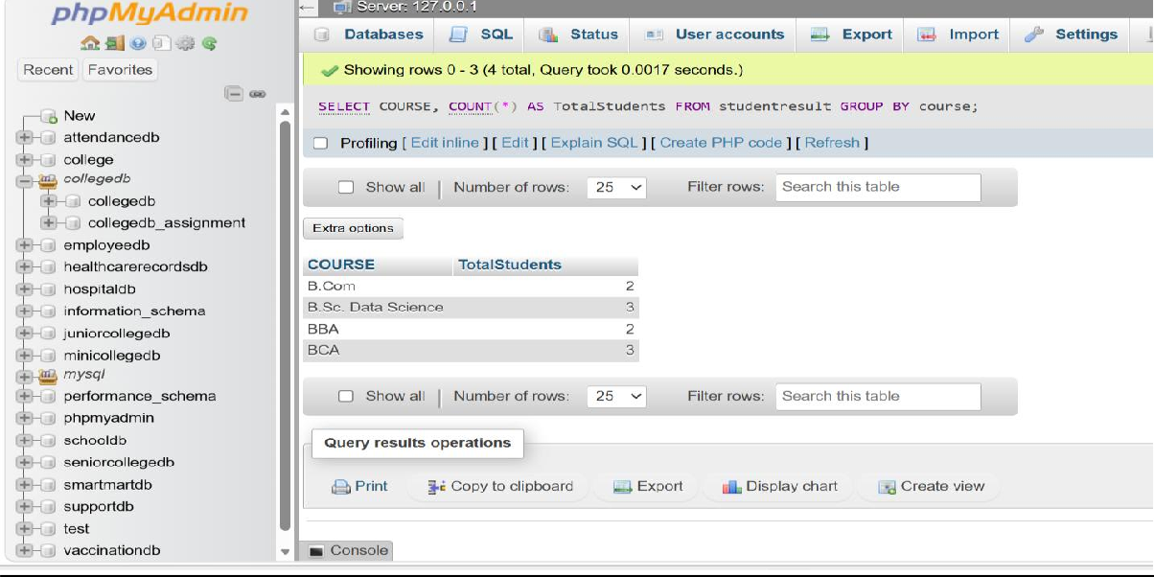

QUESTION 4
Q4) Write a MySQL query to find the average marks of students course-wise. The output should contain: Column Course AverageMarks

QUERY
SELECT course, AVG(Marks) AS AverageMarks FROM StudentResult
GROUP BY course;

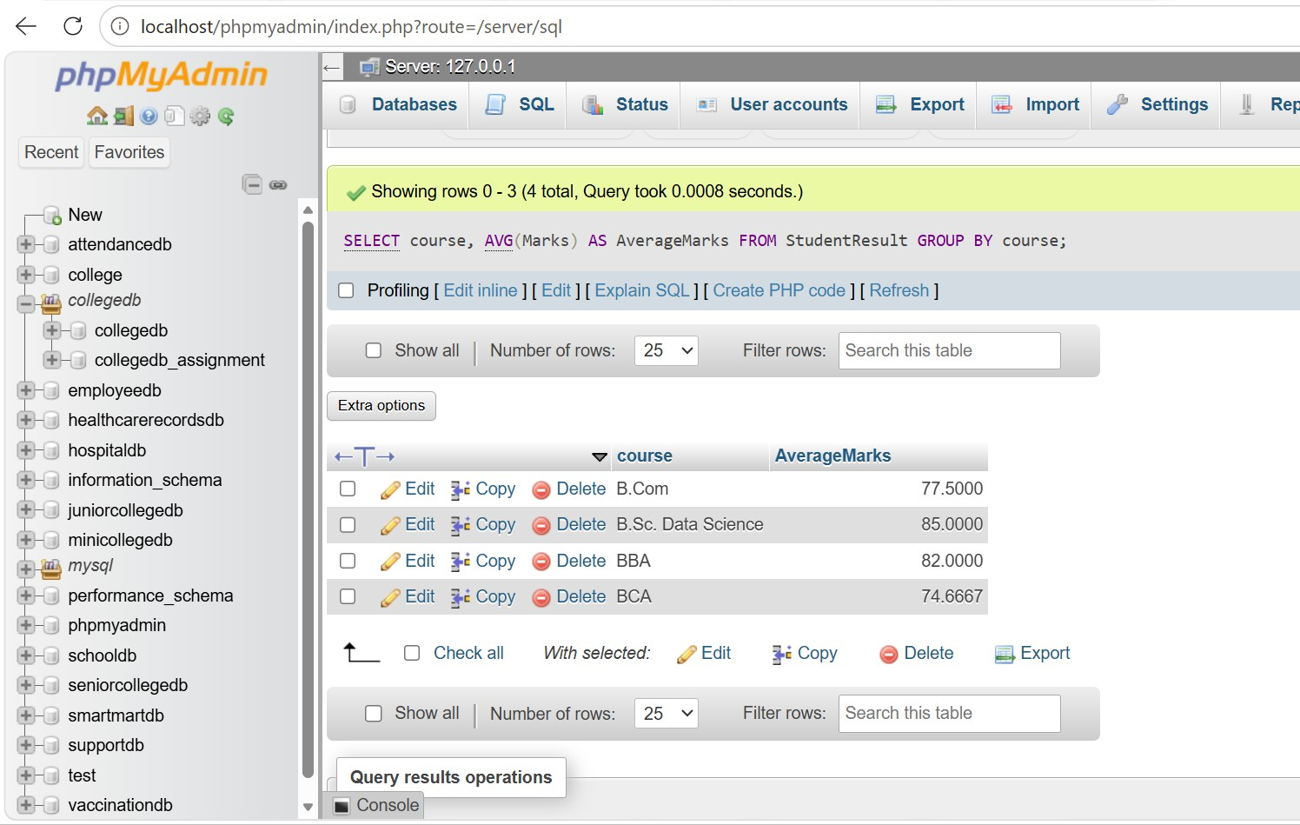

QUESTION 5
Q5) Write a MySQL query to display only those courses where the number of students is greater than 2. Use: Clause GROUP BY HAVING

QUERY
SELECT Course, COUNT(*) AS TotalStudents FROM StudentResult
GROUP BY course HAVING COUNT(*) >2;

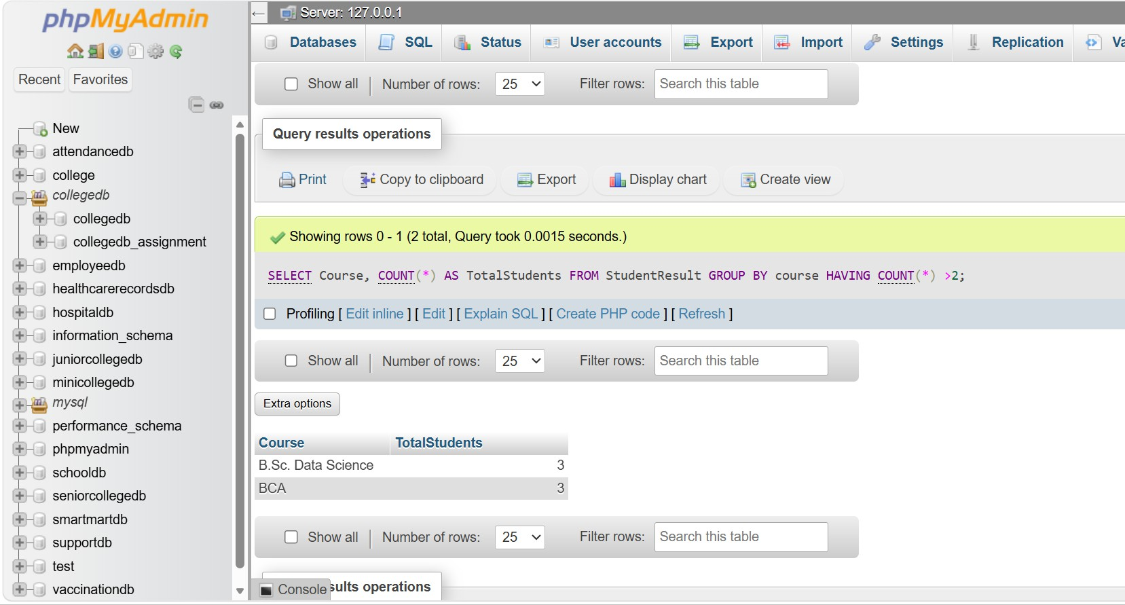

QUESTION6
Q6) Write a MySQL query to analyze course performance. The output should display: Column Course Column TotalStudents AverageMarks LowestMarks HighestMarks

QUERY

SELECT
Course,
COUNT(*) AS TotalStudents, ROUND(AVG(Marks), 2) AS AverageMarks, MIN(Marks) AS LowestMarks, MAX(Marks) AS HighestMarks
FROM StudentResult GROUP BY Course
ORDER BY AverageMarks DESC;

